**Chapter 3 Circuit Theorem**

Ex3.1 Find the **equivalent circuit** to the left of the terminals in the circuit of Figure 3-1. Then find i.

Note: Take as many solutions as possible.

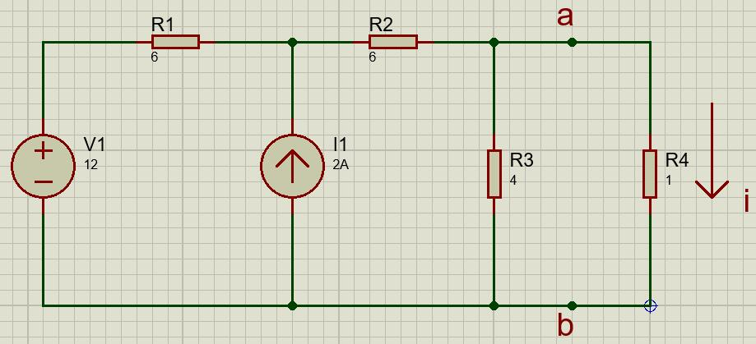

Figure 3-1

Ex3.2 Given the circuit in Figure 3-2 obtain the Norton equivalent as viewed from terminals:

(a) a-b (b) c-d.

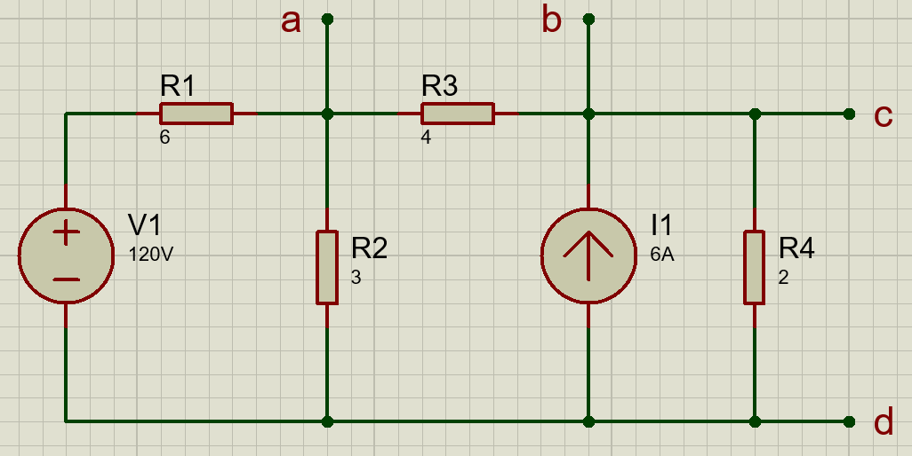

Figure 3-2

For terminal a-b:

1. Find the Thevenin’s equivalent resistance first, by transforming the circuit like the figure 3-2-1downbelow, the voltage source is treated as short circuit and the current source is in open circuit mode.

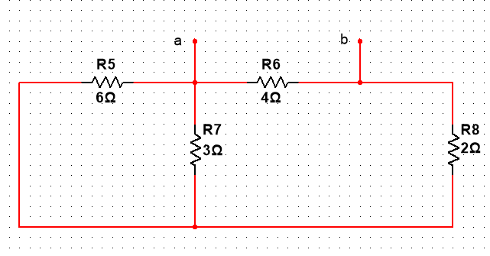

Figure 3-2-1 Thevenin’s equivalent resistance

We could rotate the figure 90 degrees clockwise to see it much more clearly.



Figure 3-2-2 the transformation of Figure 3-2-1

And we could get $R_{th}=\left(2+2\right) ||4=2 Ω$

Find the Vth by nodal analysis, the voltage source can be transformed into a current source of 20A flowing upward and is paralleled with a 6Ohm resistor. Then the figure could be set like the Figure 3-2-3 below.

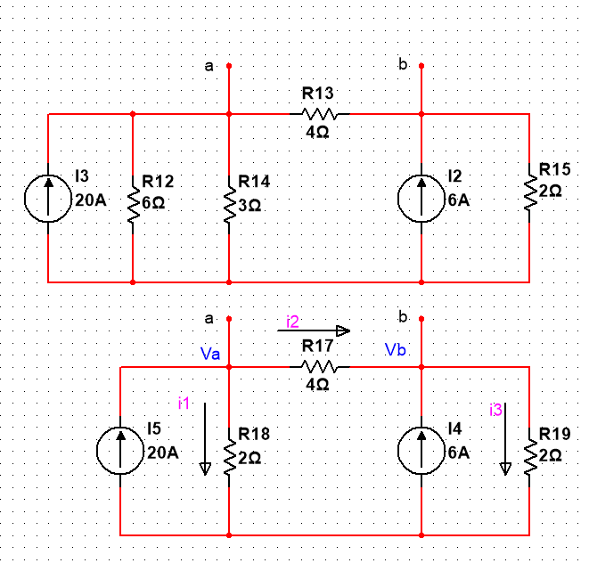

Figure 3-2-3 Vth simplified circuit

$$\left\{\begin{aligned}20=\frac{V_{a}}{2}+\frac{ V_{a}- V_{b}}{4} \\ \frac{ V_{a}- V_{b}}{4}+6=\frac{V_{b}}{2}\end{aligned}\right.$$

$$\left\{\begin{aligned}V_{a}=33V \\ V_{b}=19V\end{aligned}\right.$$

$$V_{th}= V_{a}-V_{b}=14 V$$

So according to the Norton’s Theorem, the isc is equal to the transformation of Vth which is 14 divided by 2, 7A, flowing from a to b. And the Norton’s equivalent circuit can be shown below.

The isc = 7A and Rnorton = 2Ω.

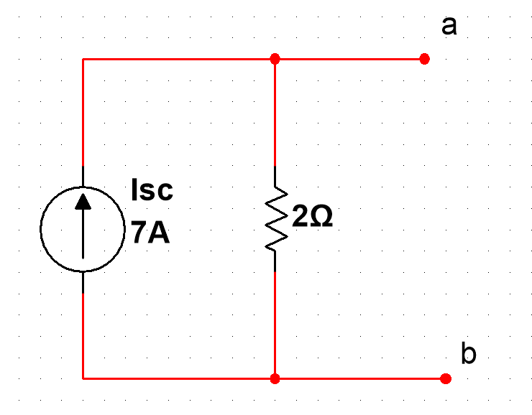

Figure 3-2-4 The Norton’s equivalent circuit

Ex3-3 Use Norton’s theorem to find V0 in the circuit of Figure 3-3.

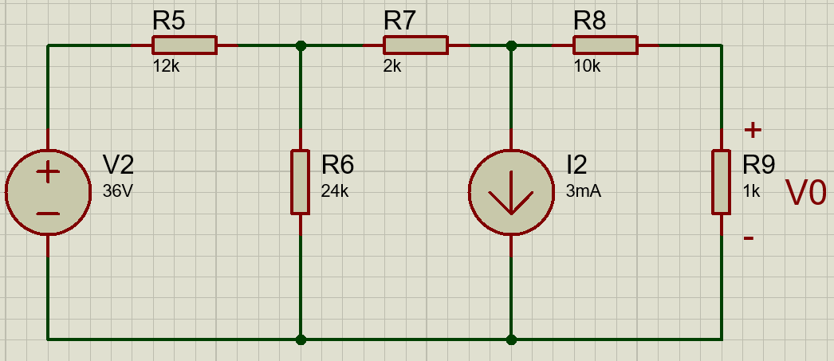

Figure 3-3